Please help me. I’m scared, and I don’t know what to do

July 5, 2023 / [Beings and Entities](https://www.creepypasta.com/category/creepypasta-stories/beings-and-entities/), [Folklore and Folktales](https://www.creepypasta.com/category/creepypasta-stories/folklore-and-folktales/), [Monsters, Creatures, and Cryptids](https://www.creepypasta.com/category/creepypasta-stories/monsters-creatures-and-cryptids/), [Nature and the Outdoors](https://www.creepypasta.com/category/creepypasta-stories/nature-and-the-outdoors/) / [Bryan A Young](https://www.creepypasta.com/tag/bryan-a-young/), [Cabin](https://www.creepypasta.com/tag/cabin/), [Skeleton](https://www.creepypasta.com/tag/skeleton/), [Titan](https://www.creepypasta.com/tag/titan/), [Urban Legend](https://www.creepypasta.com/tag/urban-legend/), [woods](https://www.creepypasta.com/tag/woods/) / 7 minutes of reading

Rate this item:Submit Rating

Rating: **8.50**/10. From 111 votes.

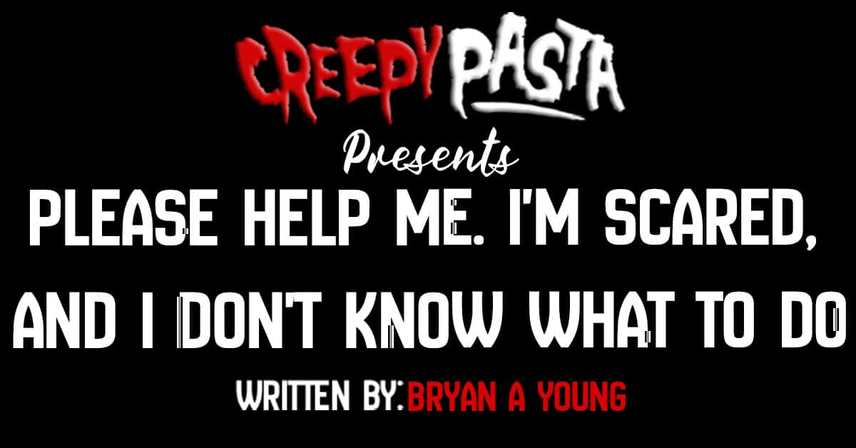

**Estimated reading time — 6 minutes**

I don’t know else how to say this other than I just saw a titanic skeleton in the woods of Lassen National Park. I understand this place is usually reserved for fun, creepy stories, but I have genuinely never been more terrified or confused.

What I’m seeing is real, and I can’t think of what to do other than beg everyone who sees this to contact me and send help.

An hour ago, I was sitting on the front porch of my cabin watching the sunset, and out of nowhere, this enormous rumbling filled the air. The type of rumbling that you can feel the vibration in your bones from. Concerned, my first thought was, “Maybe there’s an earthquake?” However, the problem with my earthquake hypothesis was that the ground wasn’t shaking. It felt more like a rhythmic vibration. Almost as if there were intervals. Clearly, it had to be something else, I thought.

Simultaneously, I hear tree branches snapping violently out in the distance behind my cabin, and I can see flocks of birds freaking out, desperately attempting to get away from that area.

Not only that, I can see a thin layer of smoke or fog among the carnage. Immediately, my mind jumped to this being an active rockslide which meant I needed to act fast and prepare myself in case anything was coming toward me.

As I scanned the area to see if anything was headed in my direction, my eyes stopped dead back around to where I had seen the first signs of trouble. For a solid minute, I couldn’t believe what I was seeing. I suppose that doesn’t really do it justice. It was more like my brain completely denied the reality of what I was literally staring at.

A hellish adaptation of a human skeleton towered over the trees. Note that I only say “skeleton” because while it was close to the proper shape of one, it was entirely covered by a black film. I would tell you that the film was the thing’s skin, but it ungulated and popped in weird spots like an unfathomably extensive collection of maggots, all moving in spastic and discontinuous patterns. Pieces of the black mass seemed to fall off as it moved through the trees and scrapped violently against branches.

Its arms hung low to its sides, and massive three-fingered hands that fell below its kneecaps made no attempt to move the obstacles in front of it. Its long neck was the most inhumane part of its anatomy. If it was a regular-sized model, I’d assume someone had borrowed it from a horse or similarly shaped animal.

Despite the goofy-looking nature of its neck, I could quickly tell its purpose was to allow the thing a much better range of movement to aid in its search for whatever it was looking for. This was made all the easier by the fact that it emitted two bright beams of light from its eyes that illuminated the woods below it. Silly as it sounds, it was like the thing had built-in searchlights that it used to scan every tiny being under its unrelenting gaze.

Advertisements

By some miracle, the skeleton was a good enough distance away from me that it either hadn’t noticed my presence or didn’t care enough to inspect me. That being said… I was still effectively pinned down. Suppose I wanted to get in my car and drive off. In that case, that’d require me going into the cabin, finding my keys, starting my car, turning on my headlights, and manually opening a decently sized steel gate just down the road. There were enough steps in my head that I could very well alert it to my position. In an emergency, maybe I could plow through the gate. Still, considering the potential damage to my car, it may not have been usable to outrun the giant to the highway.

Secondly, if I’m being honest? Seeing that monster made me too frightened to move any part of my body anyway… Some of you may call me a coward. And that’s fair. But when that early hominid part of your brain that saved our ancestors from cave lions and birds big enough to snatch children away tells you to stay put, you fucking stay put.

Unfortunately, in staying put, I damn near almost lost my hearing when the skeleton opened its mouth and emitted what sounded like a profoundly distorted mule deer call. It searched around a small area for about ten minutes, calling out at different frequencies. All this before, I shit you not, I sneezed. It stopped in the middle of its call, waited a couple seconds, and briefly switched to what sounded like a child on a loud intercom and said, “Hello?”

Advertisements

I felt my heart drop as the twisted puzzle pieces came together. Before I knew it, my hands were glued to my nose and mouth, fearing that the slightest breath would send it over to me in a frenzy. It took a single step in my direction and flashed those demonic eyes over my property. Luckily, the cabin blocked me from that wretched light, but I had clearly piqued its interest. And it was easily tall enough that it would be able to see me on the other side if it got close enough.

It took another cautious step towards me and, at a lower frequency, repeated its inhuman question. “Hello?”

At that moment, I knew I had to make a decision. Part of me was convinced there was a good chance that I would die, but that good chance would be a certainty if I didn’t act. My only real shot at survival was running into my cabin, finding my keys within a few seconds, and making a mad dash for my car. I’d have to hope that even after smashing through the gate, my car would have just enough left to get me into town. It was a poor gamble. And all in all, I’d be giving up the one safety net I had in allowing it to know exactly where I was. Still, anything had to be better than the thing tip-toeing its way here, seeing me anyway and turning me into a paste in its magot-filled throat.

Fighting every urge to run into the woods and hide under a rock, I summoned the mental energy to prepare for what was coming next. Cursing myself in my mind, I slowly and quietly turned towards the door to begin a race for my life. But just as I had done so, I heard a groan in the distance. To my surprise, it sounded like that of an actual mule deer. The skeleton must’ve picked up on the noise at the same time. Its long neck immediately snapped in the direction of the sound. Its wretched searchlight eyes began flashing rapidly, and, in the sloppy manner of a starving animal, it began to tear through the trees toward the noise as if the prey it was silently stalking just moments ago never even existed.

I took the opportunity to bolt back inside my cabin, grab my keys, and hide under my bed with my phone, a rifle, and a pillow to stifle even my most shallow breaths. It’s been about an hour since it left, and I haven’t heard anything from outside, but I’m too afraid to go out and check. I’m leaving as soon as the sun rises, but for now, I feel as trapped as I did when I was in the open. I made a quick call to 9-1-1 to try and explain to them what happened and request that they send as many units as possible out to me immediately. But as expected, they essentially thought I was on drugs and suggested that whatever I saw couldn’t hurt me and just “sleep it off.”

Texts to my friends aren’t going through because of the shitty service. Trying not to break down from the frustration, I began typing this. At this point, all I can think to do is write up this story detailing my experience and post it online in hopes that my internet miraculously works and that one of you can contact someone who believes me and send help.

Advertisements

Or, in case it kills me, keep a final testament to my last few hours on Earth. The least I can do is let the people that care about me know that I didn’t go crazy out here or get eaten by a bear. If anyone has any idea what I’m dealing with, please give me the information I’m missing. I’m unsure if there are similar stories around Lassen or if this is a first, but I need to know what’s out there if I’m going to survive the night. Here’s hoping…

Once again, this isn’t a joke for your entertainment. I’m not trying to scare anyone or be at the center of some urban legend. I’m just a really scared guy who’s desperate for someone to believe him. And I’m begging everyone that reads this, please help me.

Credit: Bryan A Young

[Reddit](https://www.reddit.com/user/bryany97)